**DREAD GULCH VALLEY**

**Created by Joshua Miller, Paul Fazekas, and Joseph Zezulak**

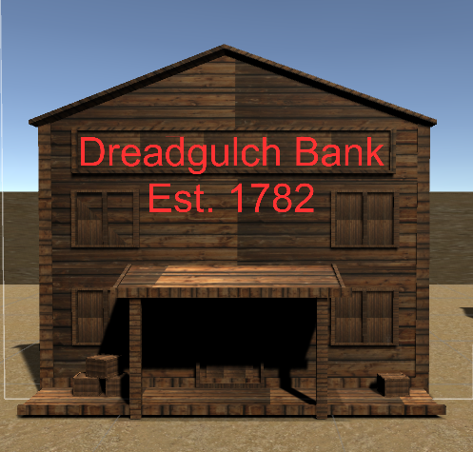

**Dread Gulch Bank in Town Level.**

**First things first......**

**To Open and run the game, there are a few things that need to be done.**

1. **Open the DGV folder you found with this manual. You will find one “exe” file and a “data” file. Both are important.**
2. **If you decide to move your game into a new location, simply copy the entire folder.**
3. **When you are ready to play click on the “exe” file.**
4. **The game can certainly be played without reading this manual, but it is always a good idea to familiarize yourself with a project before you start.**

**Enclosed in this manual are the tools you may need to play and win the game, and hopefully have a great game playing experience.**

**Game Concept: Joshua Miller**

**Game Design: Joshua Miller, Paul Fazekas, and Joseph Zezulak**

**Contents**

**Game loading instructions 2**

**Contents 3**

**Background 4**

**Movement 5**

**Weapons 5**

**Gameplay 6**

**Credits and acknowledgements 8**

**Background**

**Dread Gulch Valley is a third person adventure shooter that takes place in the Desert Southwest where our character has crash landed only to find that parts of his ship have been looted while he was trying to make repairs. You will explore Dread Gulch Valley in an effort to find the parts to your ship so you can escape, but you will encounter a number of unsavory characters. Bandits are spread throughout the valley and they will try to keep you from recovering the parts.**

**Along the way, you will find food and water that will help restore your health, and power cores that will replenish a shield for your protection. Be careful though, if you get shot, you will get hurt. If you manage to find all of the parts of your ship, you win the game and you will be able to escape the valley. Loose too much health and you will die and fail your mission.**

**In addition to the health pickups like food and water, you will have ammo pickups for three different weapons. As you start your journey, you have found a six gun that was left near your ship, but you will need more ammo soon if you have any hope of repairing your ship. Your race is not a violent one, but you are more than capable of defending yourself should the need arise. Keep in mind, these are bandits that have terrorized the surrounding area and are not innocent civilians.**

**Movement**

**You can move around the area by using the W, A, S, and D keys on the keyboard to move in any particular direction while pointing your mouse where you want to face. Should you feel the need to shoot at any of the bandits, (highly recommended in most cases), you can do this by pressing the left mouse button. Coming in contact with any pickup will have them automatically add to your ammo, health, or shield depending on what you pick up. Picking up extra food, water or ammo when you have reached your maximum won’t have any effect, but it also does you no harm.**

**You may find, however that just because something looks like it can be picked up, reached or dug up, you may have to find something to help you. For instance you may need a shovel to find something that is buried, or find something to help you get rid of a nagging boulder in your way. You will be able to find all of the tools you need on the same level as your, um, minor issue.**

**Weapons**

**In addition to the six gun you start with, you will be able to find a rifle and a shotgun, Once you have one of these you can then use the 1, 2 or 3 above the movement keys to select which weapon you would like to use. Use 1 for the six gun, 2 for the shotgun and 3 for the rifle. You must have ammo for the selected weapon to use it. You will use the left mouse button to fire.**

**Gameplay**

**You will begin the game near your grounded ship and make your way through the valley. There are a few things that will help you along the way.**

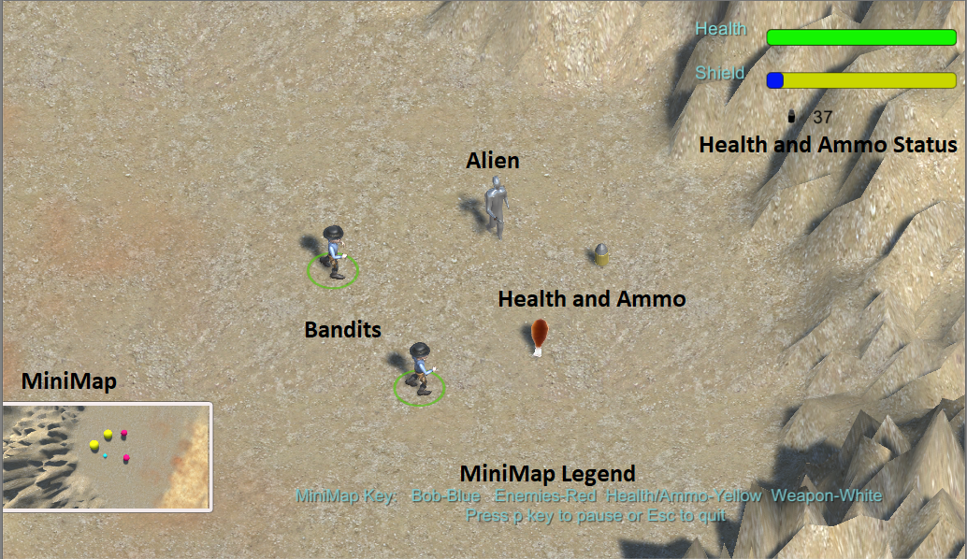

**Screenshot of game play from crash site level.**

**Health and Ammo Status:**

* **This will show your current health and shield level as well as how much ammo of your selected weapon you possess.**

**Alien:**

* **Your player character, affectionately known to us as Bob.**

**Bandits:**

* **You may find these in groups of two or three or you may find an area where they seem to spawn constantly.**

**Pickups:**

* **Along the way you will see items to restore health and ammo, power cores to restore shielding, and your ship parts to repair your vessel.**
* **You will also find a map to guide you through the canyon. To view press ‘m’**

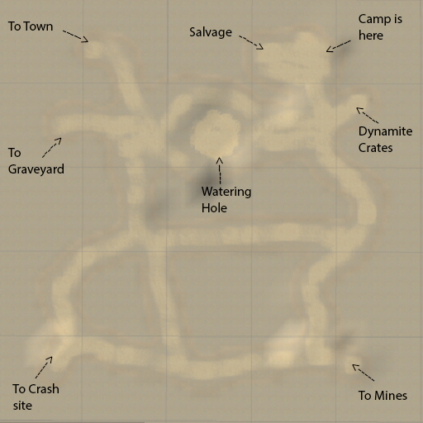

**Map of canyon created by Joseph Zezulak**

**MiniMap:**

* **You will be able to see an overview of the immediate area as well as enemies and pickups nearby. Keep in mind, your ship parts will not appear on the MiniMap. You will have to search for these.**

**MiniMap Legend:**

* **Each of the items on the map, (except the ship parts) will be shown on the MiniMap in a different color. Health and Ammo pickups will be shown in yellow, Enemies will be red, Weapons will be white, and your alien character will be blue.**
* **The parts to your ship will not appear on the MiniMap.**

CREDITS PAGE

**Assets and Models-**

Most standard assets available from Unity Standard Assets library.

Circuit board texture for ship part taken from

<http://www.chemcut.net/wp-content/uploads/2014/08/iStock_000014916558_Large300h.jpg>

Food and Water pick up models found at:

FREE Food Pack - <http://u3d.as/Mh3>

Western style models and enemies found at:

Pro Western Starter Pack <http://u3d.as/jKe>

Western style buildings in Town Level:

Western town Free VR / AR / low-poly 3D model, created by adam127. Found at:

<https://www.cgtrader.com/free-3d-models/exterior/cityscape/western-town-38de8260-ccbd-4932-a51a-d95ed33e3261>

**Sounds -**

Church Sound created by DisasterDervices at <http://www.freesound.org/people/DisasterServices/sounds/252789/>

Owl Sound created by BlueDelta at

<http://www.freesound.org/people/BlueDelta/sounds/367964/>

Miscellaneous music and sounds found at:

Western Audio and Music - <https://www.assetstore.unity3d.com/en/#!/content/67788>

Weapon sounds found at the Unity Store

Weapons of Choice – FREE by Komposite Sound

**Additional Credits –**

* All game assets were created by Joshua Miller, Paul Fazekas, and Joseph Zezulak unless otherwise noted.
* All menus designed by Joseph Zezulak.